I am useing **Microsoft Access Database** in This project

**Step 1**

Open the project

**Step 2**

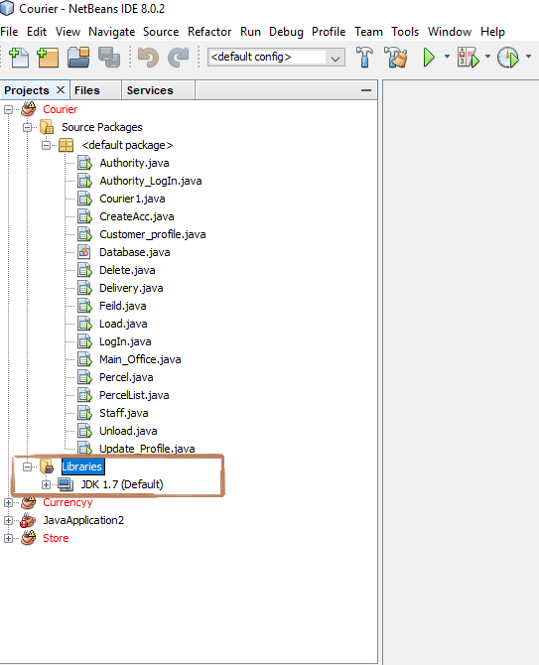

If we see only ” JDK 1.7(Default)” then we need add library. otherwise no need.

I need some library for open the project .how to get library follow the screenshot

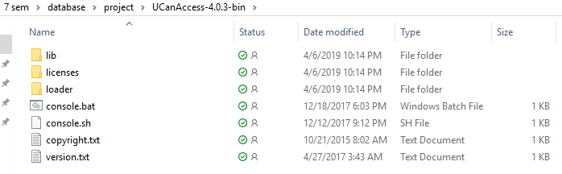

Click : UCanAccess-4.0.3-bin\lib

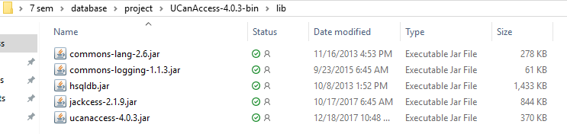

**Step 3**

How to added library

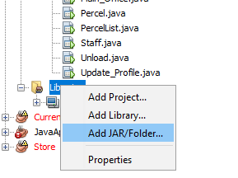

Click: Add JAR/Folder

**Step 4**

Then go to :UCanAccess-4.0.3-bin\lib(Which screenshot we give upper)

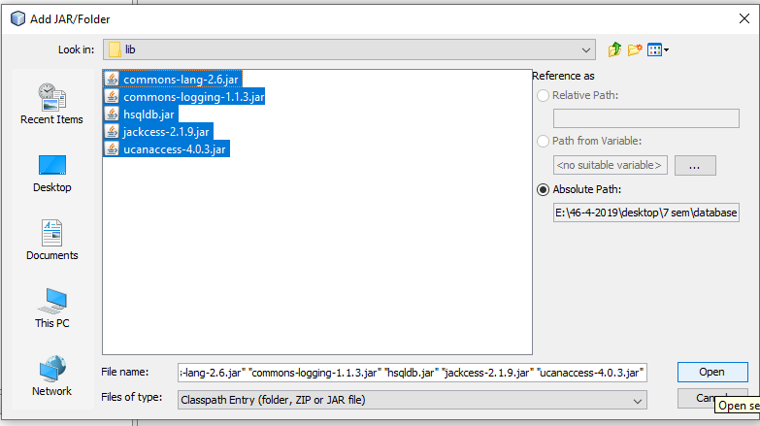

Click: Open(Select all jar file)

**Step 5**

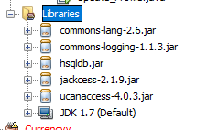

**Complete library added. Now this project is useable.**